Discrete I/O Fundamentals: GPIO configuration and electrical characteristics (EVKB‑i.MX RT1050)

1) What “discrete I/O” means in avionics
- A discrete is a binary signal—physically an electrical line that is asserted (logic “1” / true) or de‑asserted (logic “0” / false).
- In aircraft systems, discretes announce states such as WOW (Weight‑On‑Wheels), FLT/GRD (Flight/Ground), FIRE DETECT, DOOR CLOSED, or APU (Auxiliary Power Unit) READY.
- Software interacts with discretes via GPIO (General‑Purpose Input/Output) pins.
- GPIOs can be configured as inputs or outputs with features like internal pull‑ups/pull‑downs, Schmitt triggers (hysteresis), open‑drain mode, drive strength, and slew rate control.
- On the NXP i.MX RT1050, each physical pad is routed by a pin‑mux to one of several peripheral functions (GPIO, UART, SPI, etc.).
- After selecting GPIO in the mux, you configure pad electrical characteristics (pulls, slew, drive strength, hysteresis) so logic levels are reliable, immune to noise, and compatible with surrounding hardware.
- For safety‑critical avionics,
  - DAL (Design Assurance Level) software (per DO‑178C) and hardware (per DO‑254) expect discretes to be engineered for determinism
  - diagnosability (BIT—Built‑In Test),
  - tolerance to EMI/EMC (Electromagnetic Interference/Compatibility) and ESD (Electrostatic Discharge) per DO‑160.

2) Terminology and definitions (first use expanded)
- GPIO (General‑Purpose Input/Output): Configurable digital pin used as a binary input or output.
- VIH / VIL (Input High/Low Voltage): Minimum voltage recognized as logic “1” (VIH) and maximum recognized as logic “0” (VIL).
- VOH / VOL (Output High/Low Voltage): Guaranteed output voltages while driving high/low under load.
- Drive strength (mA): Sourcing/sinking capability at valid logic levels.
- Slew rate: Edge speed; slower edges reduce EMI.
- Schmitt trigger (hysteresis): Adds separate rising/falling thresholds to reject noise and slow edges.
- Pull‑up / Pull‑down: Weak resistors to rails that define a default state for otherwise floating signals.
- Push‑pull: Output stage can drive both high and low.
- Open‑drain: Output can only pull low; a pull‑up defines the high level—ideal for wired‑OR and level translation.
- Pad / Mux: “Pad” is the electrical cell at the pin; “mux” selects which internal function connects to it.
- Debounce: Filtering that removes mechanical chatter and narrow spikes.
- Wired‑OR / wired‑AND: Multiple open‑drain outputs share a line with a pull‑up; any device pulling low dominates.

3) Electrical characteristics to get right

Logic levels & supplies
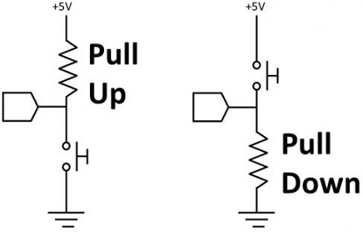
- The EVKB user I/O domain is 3.3 V (LVCMOS).
- Typical thresholds (always confirm in the data sheet) are ~0.6–0.7×VDDIO for VIH and ~0.3–0.4×VDDIO for VIL.
- Never drive GPIOs above their bank supply or below ground (beyond allowed diode/leakage currents) and observe absolute maximum ratings.

Inputs
- Pull‑ups/pull‑downs: Prevent floating inputs.
- Use pull‑up for active‑low signals; pull‑down for active‑high.

Pull-up and Pull-down Resistor
- Pull-up resistor increases the current, and the pull-down resistor is used to absorb the current.
  - Increase the voltage level.
    - When the TTL circuit drives the CMOS circuit, if the output high level of the TTL circuit is lower than the lowest high level of the CMOS circuit, then it is necessary to connect a pull-up resistor to the output terminal of the TTL to increase the value of the output high level.
    - The OC gate circuit must add a pull-up resistor to increase the high-level value of the output.
  - Increase the drive capability of the output pin.
    - In order to enhance the drive capability of the output pins, pull-up resistors are often used on some single-chip pins.
  - The N/A pin (the pin not connected) should be anti-static and anti-interference.
    - On the CMOS chip, in order to prevent damage caused by static electricity, the unused pins cannot be left floating.
    - Generally, a pull-up resistor is connected to reduce the input impedance, provide a leakage path, and improve the anti-electromagnetic interference ability of the bus.
    - Because the pin is left floating, it is easier to receive electromagnetic interference from the outside world.
  - Resistance match
    - In the long-line transmission, the resistance mismatch can easily cause the reflected wave interference.
    - In addition, the pull-down resistor makes the resistance match, which can effectively suppress the reflected wave interference.
  - Preset space state/default potential
    - Pull-up or pull-down resistors are connected to some CMOS input terminals to preset the default potential.
    - When these pins are not used, these input terminals are pulled down to low level or pulled up to high level.
    - The state when idle on the bus such as I2C is obtained by the pull-up and pull-down resistors.
  - Improve the noise tolerance of the chip input signal.
    - If the input terminal is in a high-impedance state, or in a floating state, a pull-down or pull-down resistor needs to be added at this time, so as to avoid the random level.
    - Similarly, if the output terminal is in a passive state, a pull-down or pull-down resistor needs to be added.
    - For example, the output terminal is only the collector of a transistor, thereby improving the noise tolerance of the chip input signal and enhancing the anti-interference ability through a pull-up resistor or pull-down resistor.
- Schmitt trigger: Essential for long harnesses or RC‑filtered discretes.
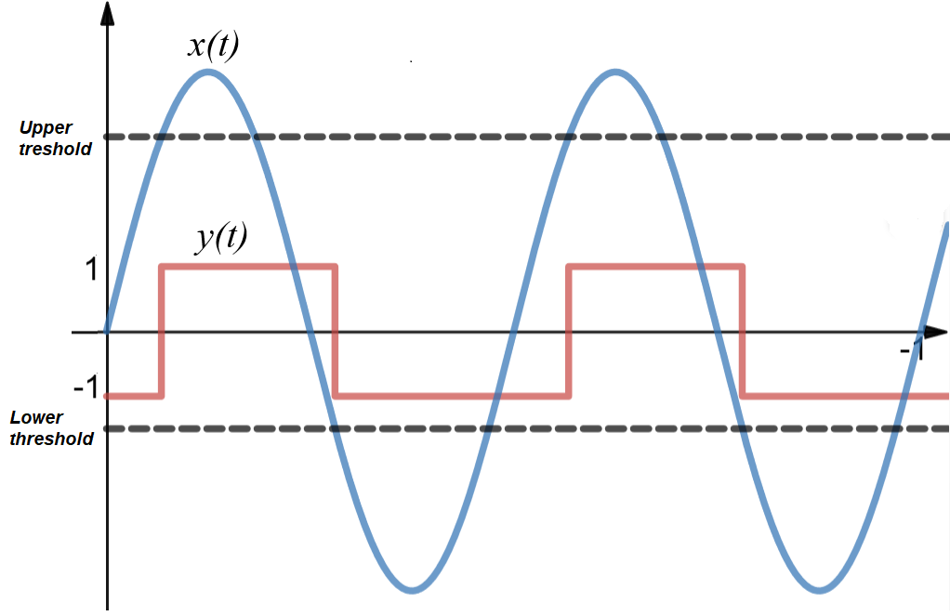

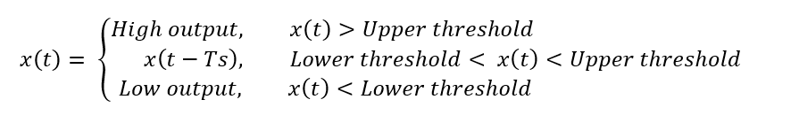
y(t)

- Glitch filtering: In software (sampling/debounce) or hardware where available.

Outputs
- Push–pull output
  - It is a circuit that uses a pair of devices to selectively source current to or sink current from a connected load.
  - It often uses a pair of power transistors or MOSFETs with matching parameters, working in a push-pull manner within the circuit.
  - In operation, only one of the two symmetrical switches is turned on at any given time, allowing the output to either source current to or sink current from the load.
  - The push-pull output stage can both improve the circuit's load capacity and enhance switching speed.
  - Useful for on‑board logic at same voltage.
  - Simply put, push-pull output can output both high and low levels, and it has driving capability at both levels.
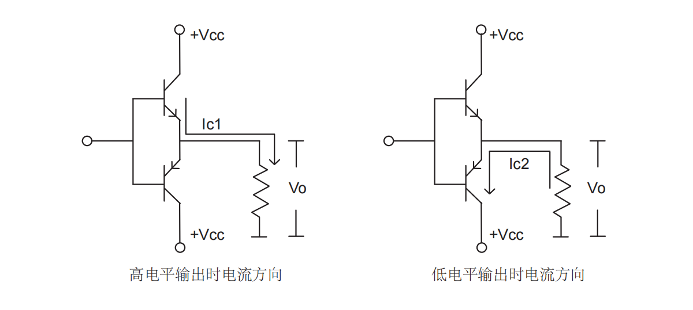
Pull
Push
- Open drain
  - outputs consist of NMOS transistors with their drains connected to the pin.
  - On the board a termination resistor or pull-up resistor is connected between the pin and the power supply and this completes the path from power to ground, via the transistor.
  - There is also on the pin a parasitic capacitor between the pin and ground.
  - The capacitor models the combined capacitance of everything attached to output pin, including the PCB track capacitance and the pin capacitance of any connected devices.
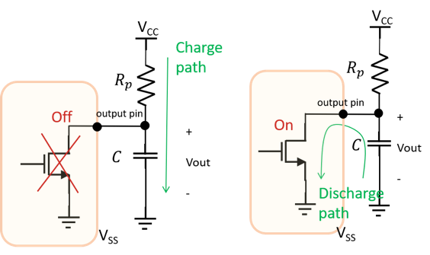
  - Is useful when when sharing a line, implementing fail‑safe wired‑OR, or level shifting (with proper external circuitry).

- Drive & slew:
  - Use the lowest drive and slowest slew that still meets timing.
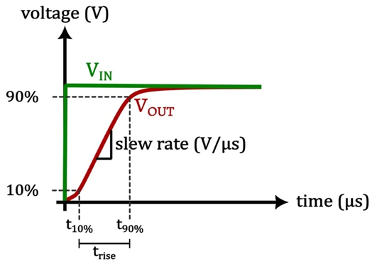

Protection & aircraft interfacing
- Aircraft systems are often 28 V nominal.
- Never connect these directly to MCU pins. Use resistor dividers, TVS (Transient Voltage Suppressor), RC filters, and isolation (optocoupler or digital isolator) as required.
- For outputs, use open‑drain transistor/MOSFET stages into aircraft discrete networks and add EMI/ESD components per DO‑160.

4) EVKB‑IMXRT1050 SDK building blocks you’ll use
- Pin mux & pad control: fsl_iomuxc.h → IOMUXC_SetPinMux() and IOMUXC_SetPinConfig() (or tool‑generated BOARD_InitPins() in pin_mux.c).
- GPIO driver: fsl_gpio.h →
  - gpio_pin_config_t (direction, default value, interrupt mode),
  - GPIO_PinInit(GPIOx, pin, &cfg), GPIO_PinWrite(), GPIO_PinRead(),
  - GPIO_PortSetInterruptConfig(), GPIO_PortClearInterruptFlags().
- Board helpers: board.c/h, fsl_debug_console.h for PRINTF(), BOARD_InitBootPins(), BOARD_InitBootClocks().
Exact LED & Button macros from your SDK’s boards/evkbimxrt1050/.../board.h:
#define LOGIC_LED_ON (0U)
#define LOGIC_LED_OFF (1U)
#define BOARD_USER_LED_GPIO GPIO1
#define BOARD_USER_LED_GPIO_PIN 9U // Pad: GPIO_AD_B0_09 → GPIO1_IO09
#define BOARD_USER_BUTTON_GPIO GPIO5 // Pad: SNVS_WAKEUP → GPIO5_IO00
#define BOARD_USER_BUTTON_GPIO_PIN (0U)
#define BOARD_USER_BUTTON_IRQ GPIO5_Combined_0_15_IRQn
#define BOARD_USER_BUTTON_IRQ_HANDLER GPIO5_Combined_0_15_IRQHandler
#define BOARD_USER_BUTTON_NAME "SW8"
The pad names above matter for electrical settings (pulls, hysteresis, open‑drain). BOARD_InitBootPins() usually configures these for you; when you need to override, use the pad constants shown in Section 8 (Lab 4).

5) Generic example—requirements → pad configuration → GPIO code
Requirement: “Provide a debounced active‑low input with noise immunity and a push‑pull output to drive an on‑board LED.”
Hardware choices: Input uses pull‑up + Schmitt trigger; software debounces. Output uses push‑pull at the lowest drive/slowest slew that still meets timing.
Software path: 1) Call BOARD_InitBootPins() (and clocks/console) to set mux & baseline pad config. 2) Initialize GPIO pins via GPIO_PinInit(). 3) If using interrupts on the input, configure GPIO_PortSetInterruptConfig() and enable its NVIC IRQ. 4) Read inputs (poll or ISR) and write outputs.

6) Realistic avionics use case—WOW (Weight‑On‑Wheels) with diagnostics
Scenario: An LRU (Line‑Replaceable Unit) ingests a WOW discrete via an isolated interface, filters bounce/spikes, votes samples for truth, timestamps edges for maintenance logs to the CMC (Central Maintenance Computer), and asserts a FLT/GRD (Flight/Ground) status discrete on an open‑drain output so multiple LRUs can share the line (wired‑OR). Power‑up and periodic BIT (Built‑In Test) detect stuck‑at faults.
Engineering choices: Input with internal pull‑up + hysteresis + 5 ms debounce; output as open‑drain (external pull‑up on the backplane). Software records both raw and filtered states with timestamps.

7) Hands‑on labs on EVKB‑IMXRT1050 (using SDK macros from board.h)
All labs assume a bare‑metal project with BOARD_InitBootPins(), BOARD_InitBootClocks(), and BOARD_InitDebugConsole() available. The exact LED and button pins/macros are taken from the SDK, so you do not hardcode GPIO banks/pins.

Lab 0 — Project skeleton
#include "board.h"
#include "pin_mux.h"
#include "clock_config.h"
#include "fsl_debug_console.h"
int main(void) {
BOARD_InitBootPins();
BOARD_InitBootClocks();
BOARD_InitDebugConsole();
PRINTF("Discrete I/O lab start\r\n");
while (1) { __NOP(); }
}

Lab 1 — Output: blink the user LED with SDK macros
Because board.h defines the LED logic and location, you can use either the convenience macros or the GPIO driver directly. Here’s a clean pattern using the driver and the logic constants:
#include "board.h"
#include "fsl_gpio.h"
static void led_init(void) {
gpio_pin_config_t led_cfg = {
.direction = kGPIO_DigitalOutput,
.outputLogic = LOGIC_LED_OFF,
.interruptMode = kGPIO_NoIntmode
};
GPIO_PinInit(BOARD_USER_LED_GPIO, BOARD_USER_LED_GPIO_PIN, &led_cfg);
}
static inline void led_set(int on) {
GPIO_PinWrite(BOARD_USER_LED_GPIO, BOARD_USER_LED_GPIO_PIN, on ? LOGIC_LED_ON : LOGIC_LED_OFF);
}
static inline void led_toggle(void) {
GPIO_PinWrite(BOARD_USER_LED_GPIO, BOARD_USER_LED_GPIO_PIN,
GPIO_PinRead(BOARD_USER_LED_GPIO, BOARD_USER_LED_GPIO_PIN) ^ 0x1);
}
int main(void) {
BOARD_InitBootPins();
BOARD_InitBootClocks();
BOARD_InitDebugConsole();
led_init();
PRINTF("LED blink using board.h macros (active-%s)\r\n",
LOGIC_LED_ON ? "high" : "low");
while (1) {
led_toggle();
SDK_DelayAtLeastUs(250000U, SystemCoreClock); // 250 ms
}
}
Electrical reasoning: the LED is local and shares 3.3 V, so push‑pull is fine. If edges are noisy in EMI testing, reduce drive strength and set slow slew in the pad config (see Lab 4).

Lab 2 — Input: read SW8 with pull‑up, Schmitt trigger, interrupt, and debounce
We’ll use the exact button macros from board.h:
#include "board.h"
#include "fsl_gpio.h"
#include "fsl_common.h"
static volatile uint8_t s_buttonStable; // 1=not pressed (since SW8 is active-low), 0=pressed
static void button_init(void) {
gpio_pin_config_t in_cfg = {
.direction = kGPIO_DigitalInput,
.outputLogic = 0U,
.interruptMode = kGPIO_IntRisingOrFallingEdge
};
GPIO_PinInit(BOARD_USER_BUTTON_GPIO, BOARD_USER_BUTTON_GPIO_PIN, &in_cfg);
GPIO_PortClearInterruptFlags(BOARD_USER_BUTTON_GPIO, 1UL << BOARD_USER_BUTTON_GPIO_PIN);
GPIO_PortSetInterruptConfig(BOARD_USER_BUTTON_GPIO, BOARD_USER_BUTTON_GPIO_PIN,
kGPIO_IntRisingOrFallingEdge);
NVIC_ClearPendingIRQ(BOARD_USER_BUTTON_IRQ);
NVIC_EnableIRQ(BOARD_USER_BUTTON_IRQ);
}
void BOARD_USER_BUTTON_IRQ_HANDLER(void) {
GPIO_PortClearInterruptFlags(BOARD_USER_BUTTON_GPIO, 1UL << BOARD_USER_BUTTON_GPIO_PIN);
// Simple time-based debounce: re-sample after 5 ms
SDK_DelayAtLeastUs(5000U, SystemCoreClock);
uint8_t raw = GPIO_PinRead(BOARD_USER_BUTTON_GPIO, BOARD_USER_BUTTON_GPIO_PIN); // 0 when pressed
s_buttonStable = raw ? 1U : 0U;
__DSB(); __ISB();
}
int main(void) {
BOARD_InitBootPins();
BOARD_InitBootClocks();
BOARD_InitDebugConsole();
// Ensure SNVS mux clock is on if you override pin mux manually elsewhere
// CLOCK_EnableClock(kCLOCK_IomuxcSnvs);
// LED for feedback
gpio_pin_config_t led_cfg = { kGPIO_DigitalOutput, LOGIC_LED_OFF, kGPIO_NoIntmode };
GPIO_PinInit(BOARD_USER_LED_GPIO, BOARD_USER_LED_GPIO_PIN, &led_cfg);
button_init();
PRINTF("SW8 interrupt+debounce: press to toggle LED\r\n");
uint8_t last = 1U;
while (1) {
if (s_buttonStable != last) {
last = s_buttonStable;
if (s_buttonStable == 0U) { // pressed
GPIO_PinWrite(BOARD_USER_LED_GPIO, BOARD_USER_LED_GPIO_PIN,
GPIO_PinRead(BOARD_USER_LED_GPIO, BOARD_USER_LED_GPIO_PIN) ^ 0x1);
}
}
}
}
Electrical reasoning: the input pad should have pull‑up and hysteresis enabled (see Lab 4 for explicit pad settings). Software adds a deterministic 5 ms debounce.

Lab 3 — Toward WOW: edge timestamps + 3‑of‑5 voting (using SW8 as a stand‑in)
This skeleton shows timestamping edges and producing a robust “truth” via majority voting. Replace SW8 with your isolated WOW input in a real LRU.
#include "board.h"
#include "fsl_gpio.h"
#include "fsl_gpt.h"
static volatile uint32_t s_edgeTimeUs;
static volatile uint8_t s_wowTruth;
static void timers_init_1MHz(void) {
CLOCK_EnableClock(kCLOCK_Gpt1);
gpt_config_t cfg;
GPT_GetDefaultConfig(&cfg);
cfg.clockSource = kGPT_ClockSource_Periph;
cfg.divider = CLOCK_GetFreq(kCLOCK_PerClk) / 1000000U; // 1 MHz
cfg.enableFreeRun = true;
GPT_Init(GPT1, &cfg);
GPT_StartTimer(GPT1);
}
static inline uint32_t micros(void) { return GPT_GetCurrentTimerCount(GPT1); }
// Use board macros for SW8
void BOARD_USER_BUTTON_IRQ_HANDLER(void) {
GPIO_PortClearInterruptFlags(BOARD_USER_BUTTON_GPIO, 1UL << BOARD_USER_BUTTON_GPIO_PIN);
s_edgeTimeUs = micros();
// 3-of-5 voting over the last 5 ms samples
static uint8_t window[5] = {1,1,1,1,1};
static uint8_t idx = 0;
// SW8 is active-low: 0 = asserted → treat as WOW=1 when pressed
uint8_t raw = GPIO_PinRead(BOARD_USER_BUTTON_GPIO, BOARD_USER_BUTTON_GPIO_PIN);
uint8_t logical = (raw == 0U) ? 1U : 0U;
window[idx] = logical; idx = (idx + 1) % 5;
uint8_t sum = window[0] + window[1] + window[2] + window[3] + window[4];
s_wowTruth = (sum >= 3U) ? 1U : 0U;
__DSB(); __ISB();
}
int main(void) {
BOARD_InitBootPins();
BOARD_InitBootClocks();
BOARD_InitDebugConsole();
timers_init_1MHz();
// Configure LED and SW8
gpio_pin_config_t led_cfg = { kGPIO_DigitalOutput, LOGIC_LED_OFF, kGPIO_NoIntmode };
GPIO_PinInit(BOARD_USER_LED_GPIO, BOARD_USER_LED_GPIO_PIN, &led_cfg);
gpio_pin_config_t in_cfg = { kGPIO_DigitalInput, 0U, kGPIO_IntRisingOrFallingEdge };
GPIO_PinInit(BOARD_USER_BUTTON_GPIO, BOARD_USER_BUTTON_GPIO_PIN, &in_cfg);
GPIO_PortClearInterruptFlags(BOARD_USER_BUTTON_GPIO, 1UL << BOARD_USER_BUTTON_GPIO_PIN);
GPIO_PortSetInterruptConfig(BOARD_USER_BUTTON_GPIO, BOARD_USER_BUTTON_GPIO_PIN,
kGPIO_IntRisingOrFallingEdge);
NVIC_EnableIRQ(BOARD_USER_BUTTON_IRQ);
PRINTF("WOW voting demo (press %s): timestamps in us will print on edges)\r\n",
BOARD_USER_BUTTON_NAME);
uint32_t lastEdge = 0;
while (1) {
if (s_edgeTimeUs != lastEdge) {
lastEdge = s_edgeTimeUs;
PRINTF("Edge @ %u us, WOW truth=%u\r\n", (unsigned)lastEdge, (unsigned)s_wowTruth);
// Visualize truth on LED
GPIO_PinWrite(BOARD_USER_LED_GPIO, BOARD_USER_LED_GPIO_PIN,
s_wowTruth ? LOGIC_LED_ON : LOGIC_LED_OFF);
}
}
}

Lab 4 — Electrical pad settings you should know (pulls, hysteresis, drive, slew, open‑drain)
When you must override or audit the electrical configuration, use the correct pad constants:
- LED (GPIO1_IO09) pad is GPIO_AD_B0_09 → IOMUXC_GPIO_AD_B0_09_GPIO1_IO09.
- SW8 (GPIO5_IO00) pad is SNVS_WAKEUP → IOMUXC_SNVS_WAKEUP_GPIO5_IO00.
#include "fsl_iomuxc.h"
static void pad_config_audit(void) {
// Ensure mux clocks are on if not handled by BOARD_InitBootPins
CLOCK_EnableClock(kCLOCK_Iomuxc);
CLOCK_EnableClock(kCLOCK_IomuxcSnvs);
// LED: push-pull output, slow slew, modest drive
IOMUXC_SetPinMux(IOMUXC_GPIO_AD_B0_09_GPIO1_IO09, 0U);
IOMUXC_SetPinConfig(IOMUXC_GPIO_AD_B0_09_GPIO1_IO09,
IOMUXC_SW_PAD_CTL_PAD_PKE_MASK | // pull/keeper enable
IOMUXC_SW_PAD_CTL_PAD_PUE_MASK | // pull selected (vs keeper)
IOMUXC_SW_PAD_CTL_PAD_PUS(2U) | // pull-up ~100k (device-specific)
IOMUXC_SW_PAD_CTL_PAD_SPEED(2U) | // medium speed
IOMUXC_SW_PAD_CTL_PAD_DSE(2U) | // moderate drive
0U /* ODE=0 push-pull, HYS not needed on output */);
// SW8 input: enable pull-up + hysteresis; slow slew is fine
IOMUXC_SetPinMux(IOMUXC_SNVS_WAKEUP_GPIO5_IO00, 0U);
IOMUXC_SetPinConfig(IOMUXC_SNVS_WAKEUP_GPIO5_IO00,
IOMUXC_SW_PAD_CTL_PAD_PKE_MASK |
IOMUXC_SW_PAD_CTL_PAD_PUE_MASK |
IOMUXC_SW_PAD_CTL_PAD_PUS(2U) | // pull-up
IOMUXC_SW_PAD_CTL_PAD_HYS_MASK | // Schmitt trigger
IOMUXC_SW_PAD_CTL_PAD_DSE(2U)); // modest drive (applies if used as output)
}
The exact numeric values for PUS, DSE, and SPEED are device/SDK‑version specific; the pattern above is what to audit: pull + hysteresis for inputs, slow slew/low drive unless timing demands otherwise, and open‑drain (ODE) if you configure a shared aircraft discrete output.

8) Strong avionics‑grade scenarios to simulate
- WOW with transient spikes: Inject brief pulses; show Schmitt + voting reject them. Log edge timestamps and report “Noise event ignored; no state change.”
- Wired‑OR FLT/GRD line: Tie two open‑drain outputs with a single pull‑up. Show either controller can assert ground. Demonstrate fault containment when one MCU resets.
- Stuck‑at BIT: Short the WOW input to ground; detect stuck‑low during maintenance stimulus and report to the CMC (Central Maintenance Computer) (log to console for the lab).
- EMI mitigation tradeoff: Observe ringing at high toggle rates; then reduce drive/slow slew via pad config and measure improvement.

9) Best practices (hardware + software)
- Match electrical domains: Never expose 28 V aircraft discretes directly to MCU pins. Use dividers, TVS, isolation.
- Fail‑safe states: Choose pulls and output types so a broken wire or power‑down yields the least hazardous interpretation.
- Enable hysteresis: Turn on Schmitt trigger for external discretes.
- Respect pull strengths: Disable MCU pulls if a strong external pull exists to avoid undesired dividers.
- Debounce deterministically: Use a stable time base (SysTick or GPT). Record raw and filtered states.
- BIT for stuck‑at/open: Exercise inputs/outputs at power‑up and periodically; use loopbacks when possible.
- Tame EMI: Use the lowest drive and slowest slew that meet timing; add small series resistors if needed.
- ISRs stay short: Clear flags first; defer work to main loop/task.
- Document bank supplies & mux: Keep a one‑pager mapping pads → banks → rails; control pin_mux.c under configuration management.
- Traceability: Requirements → pad config → code → tests; keep pin_mux.c settings under revision control.

10) Assessment checklist
- Asserted polarity and fail‑safe state documented?
- Pad configs explicitly set pulls, hysteresis, slew, drive, and open‑drain (as needed)?
- Debounce/filter rationale stated (e.g., 5 ms)?
- BIT covers stuck‑high/low and open‑circuit?
- Edge timestamps logged for maintenance?
- EMI/ESD robustness considered (lab + DO‑160 assumptions)?

11) Notes for later ARINC 429 sessions
ARINC (Aeronautical Radio, Incorporated) 429 is a differential, unidirectional serial bus. While not a discrete itself, you frequently manage enables, health discretes, and label‑present lines as GPIOs alongside the ARINC transceiver (e.g., on an ADK‑8582 interfaced over UART). The GPIO concepts above—pad config, open‑drain, debounce, BIT—apply directly to those companion lines.

Implementation guidance
- Prefer the board macros shown here instead of hardcoding banks/pins. This matches the SDK and reduces porting effort.
- Use the MCUXpresso Pins Tool to generate pin_mux.c and explicitly include the electrical options you require (pulls, hysteresis, drive, slew, open‑drain). Keep the generated file under configuration control.

